**Salman Ahmed Khan**

**19K-1043**

**CN Lab 4**

**Q1**

Socket Programming is used to connect two nodes on a network to communicate with each other. Server uses the listen socket while client reach to connect to a server. The one socket node listens on a particular port of an IP and other socket forms connection. Thus, it is a way to communicate two computers on a network.

**Q2**

In order to make a socket a listen only connection, the listen parameter is used to handle it. If passed 1 in a parameter, the socket becomes a listen only connection. e.g., Listen (1)

**Q3**

**Server.java**

import java.io.*;

import java.net.*;

public class MyServer {

public static void main(String[] args){

try{

ServerSocket ss=new ServerSocket(6666);

Socket s=ss.accept();//establishes connection

DataInputStream dis=new DataInputStream(s.getInputStream());

String str=(String)dis.readUTF();

System.out.println("message= "+str);

ss.close();

}catch(Exception e){System.out.println(e);}

}

}

**Client.java**

import java.io.*;

import java.net.*;

public class MyClient {

public static void main(String[] args) {

try{

Socket s=new Socket("localhost",6666);

DataOutputStream dout=new DataOutputStream(s.getOutputStream());

dout.writeUTF("Hello Server");

dout.flush();

dout.close();

s.close();

}catch(Exception e){System.out.println(e);}

}

}

**Q4**

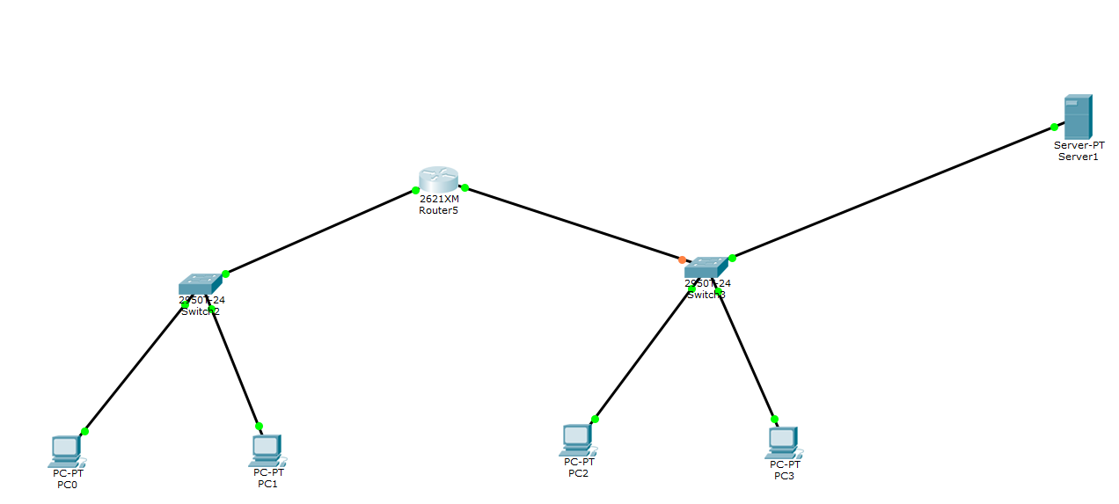

**Assigning the DHCP IP to switches by using router**

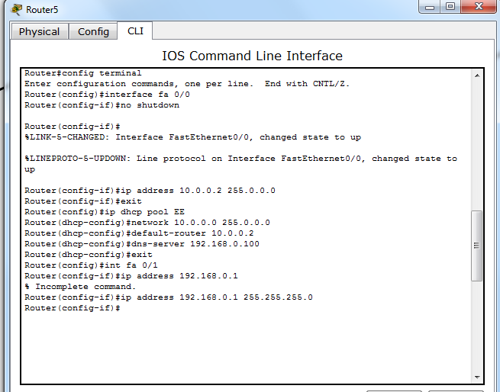

**Configuring IP and Gateway of Server**

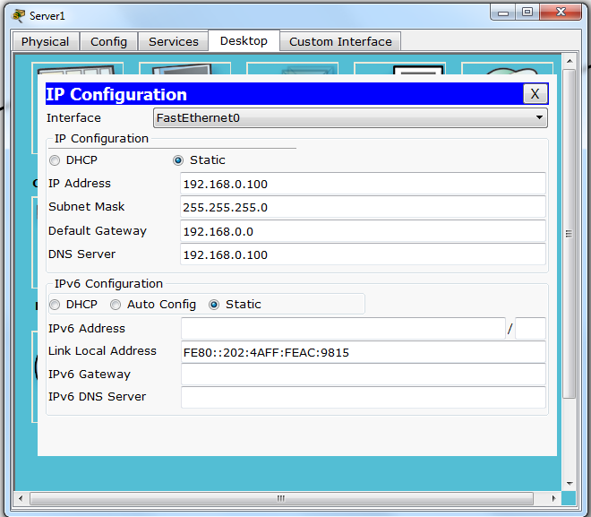

**Assigning IP address**

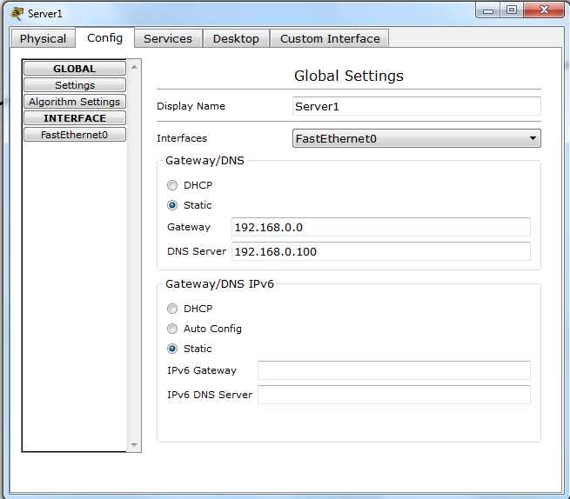

**Fetching Website from Server**

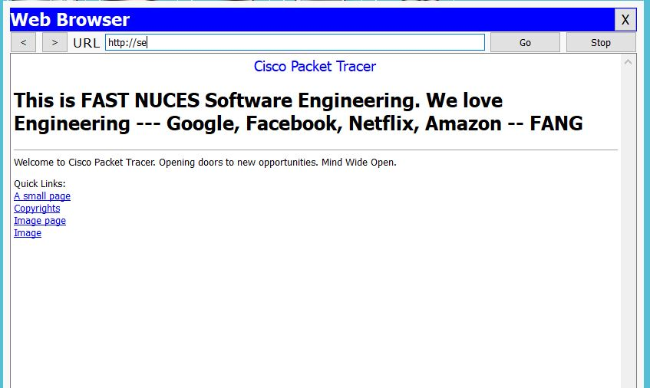

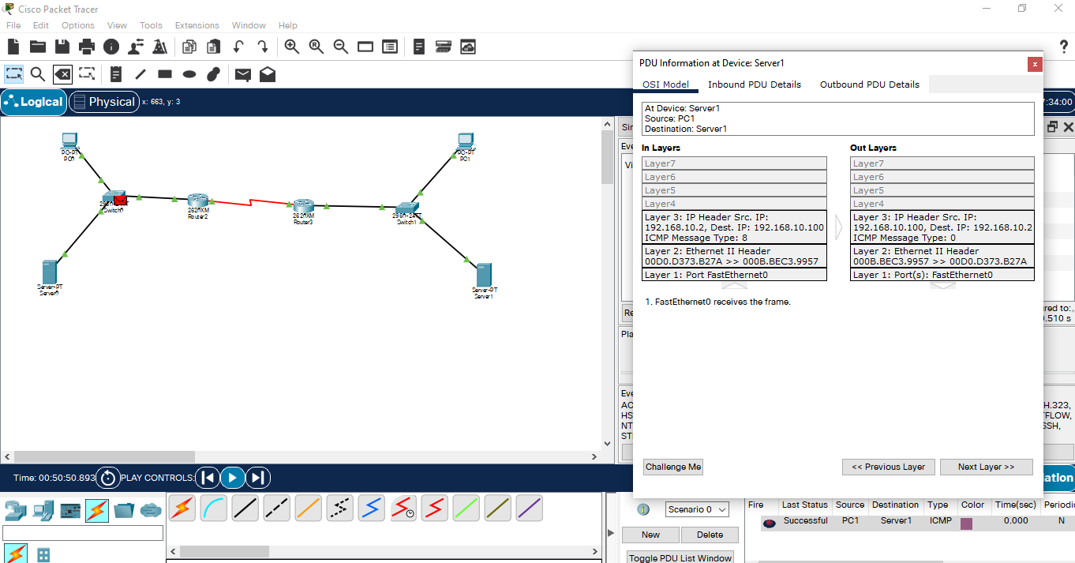

**DNS Information**

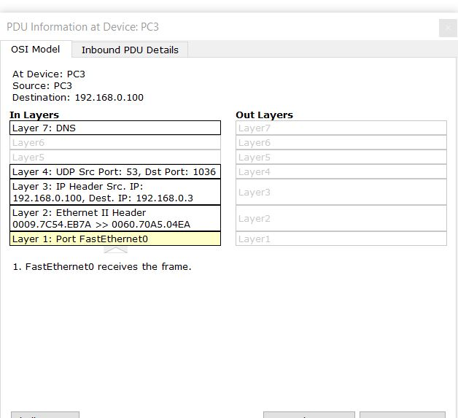

**TCP Information**

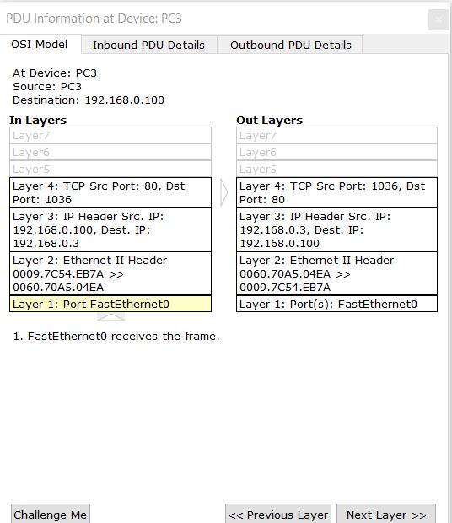

**Socket Programming**

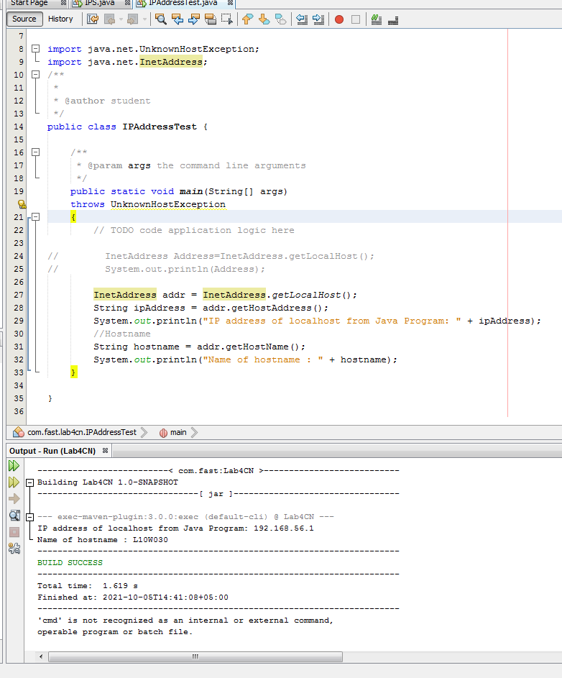

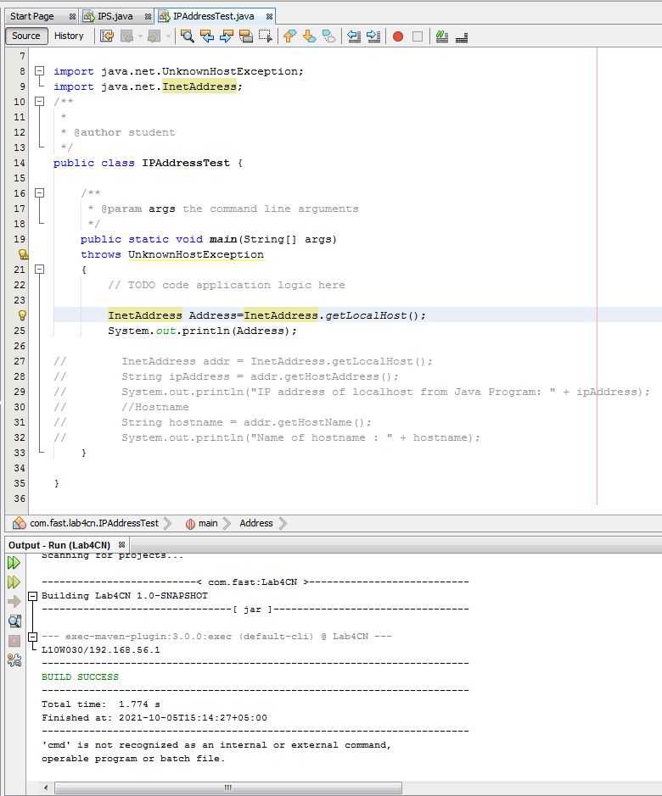

**OSI Layer**



**WireShark**

